COURSE 1 → WEEK 2 NOTES.

Topic 1.6 of the book.
Visualizing the Numeric data:

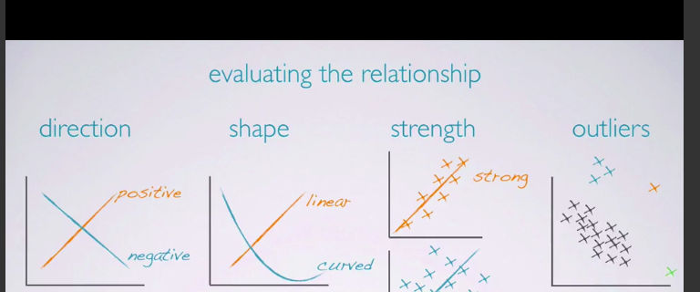
histogram helps us to determine the dist of the data, it provides a view of data density.

Skewness : dists are skewed to the side of the long tail.

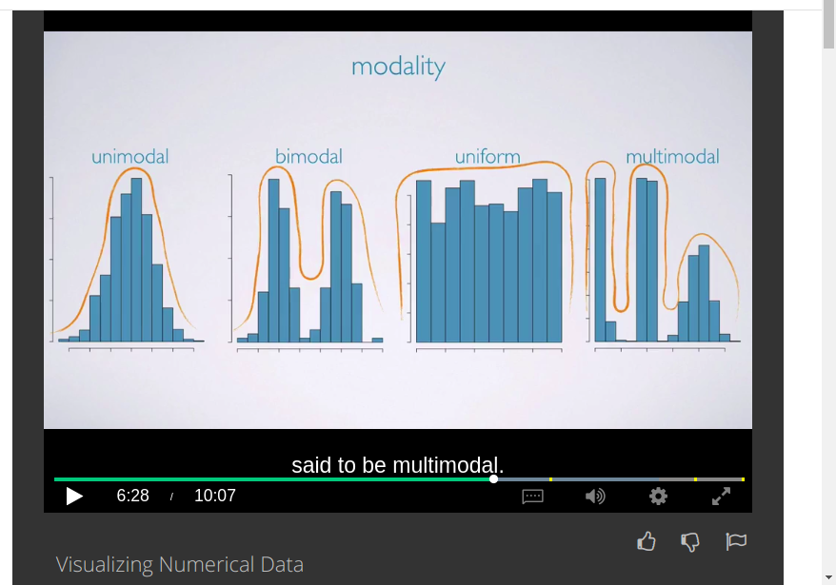
The bimodal shows that there are 2 groups in a data set while uniform shows that there’s no trend every value in a data is equally likely to occur.

While symmetric shows that most of the readings/values in a data set are around the mean.
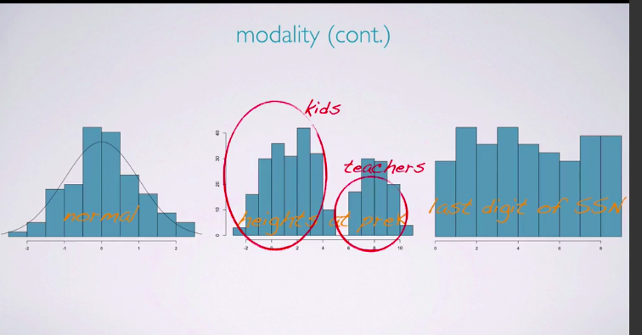
Here the last graph of the above pic is the plot of the last digit of Social security number of US citizen ,which is a Uniform dist as expected.

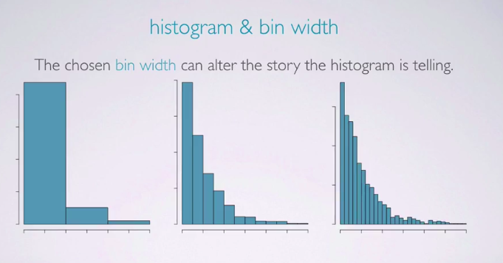
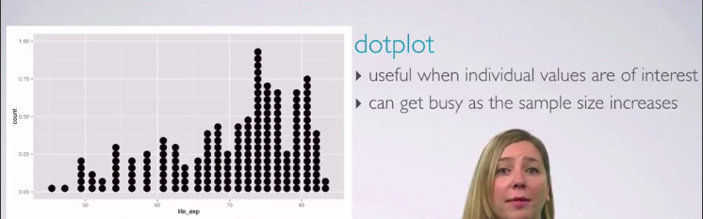

BOX PLOTS: useful for highlighting outliers and IQR.(inter quartile range):

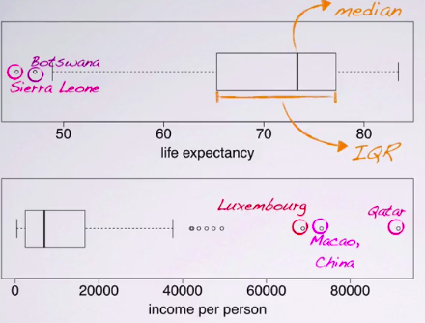
they donot show the modality, but they do show skewness.

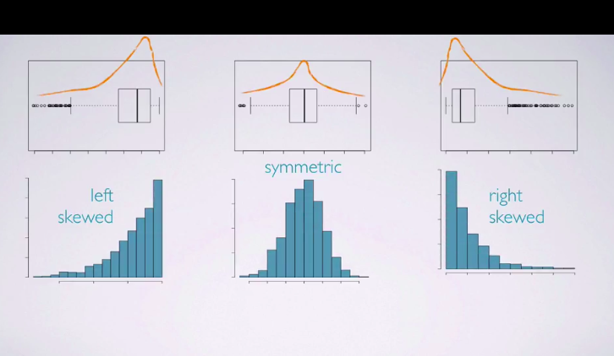

INTENSITY MAP:

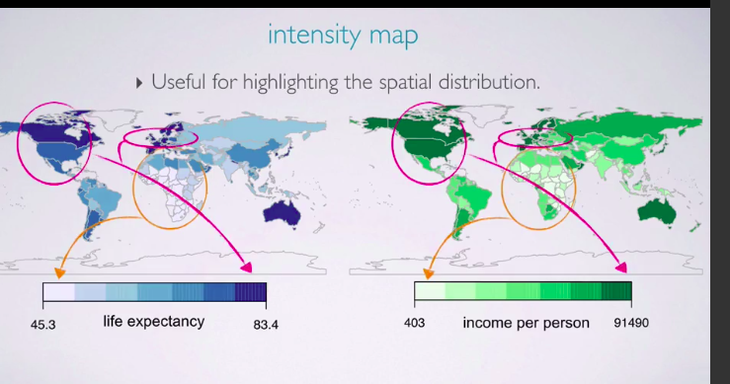
MEASURE OF CENTER:
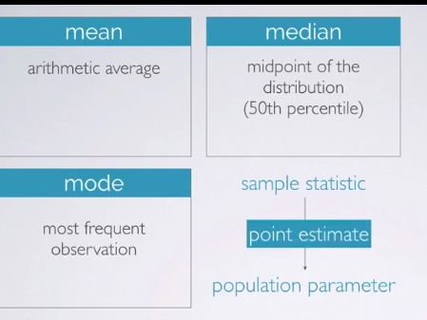
Another key characteristic that is of interest is the center of the distribution, commonly used measures of center are the mean, which is simply the arithmetic average. The median, which is the mid point of the distribution or in other words the 50th percentile and the mode which is the most frequent observation. If these measurements are calculated from a sample, they're called sample statistics. Sample statistics are point estimates for the unknown population parameters.

We usually use letters from the Latin alphabet when denoting sample statistics, and letters from the Greek alphabet when denoting population parameters. For example, the sample mean is x bar and the population mean is mu.
Which statement is true:

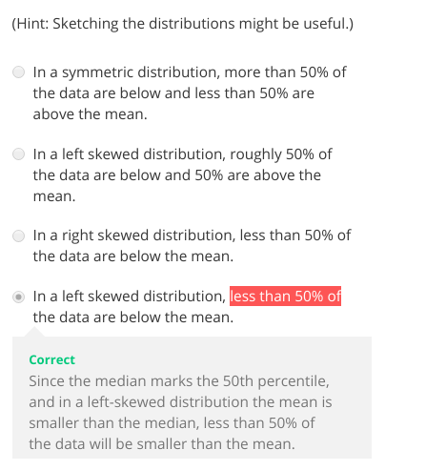

less than 50 is noticable.

Measure of spreads:

range,variance,std and IQR.

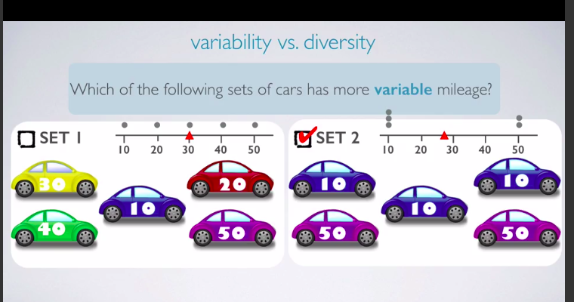
The set 1 is more diverse but the set 2 is more variable bcz the means are 30 and 26 which is roughly equal but the values aren’t centered in the set 2 they are at end points.

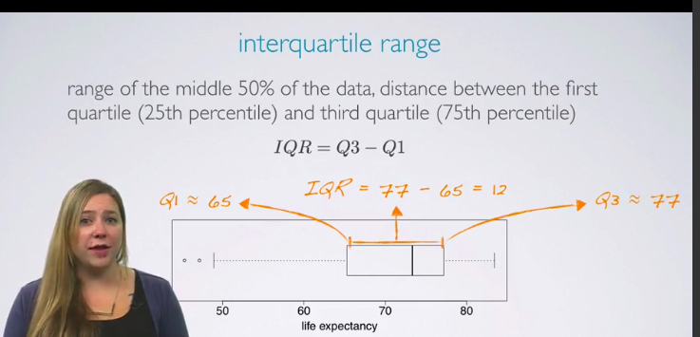

Robust statistics:

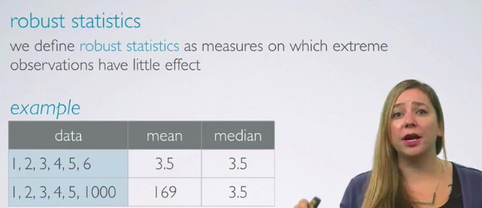

median is more robust then the mean because it doesn’t relies on the extreme values.

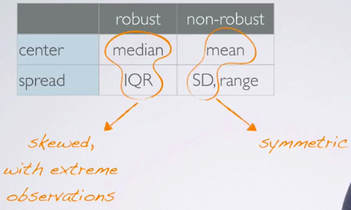

Robusts are used for skewed distributions while we use mean and std for symmetric.

